How to Apply Styles Using the style Attribute: The style attribute in HTML allows you to apply CSS rules directly to individual elements. This is called inline CSS, and it is written inside the HTML tag itself. Each style rule is defined as a key-value pair, separated by a colon and followed by a semicolon.
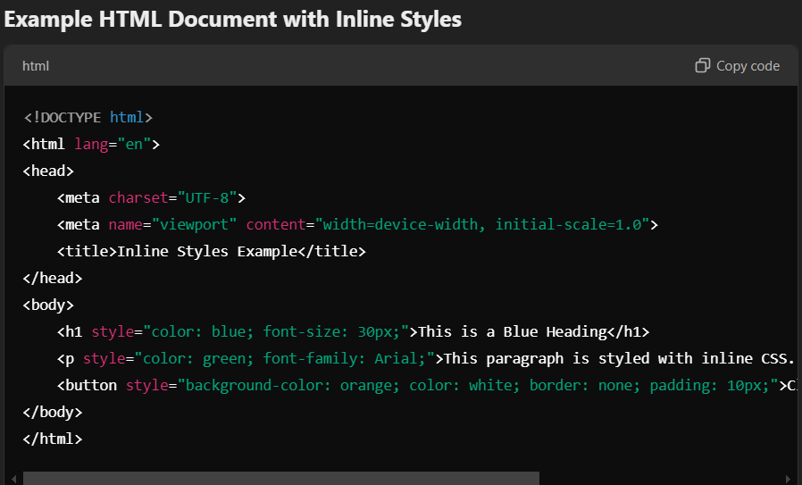

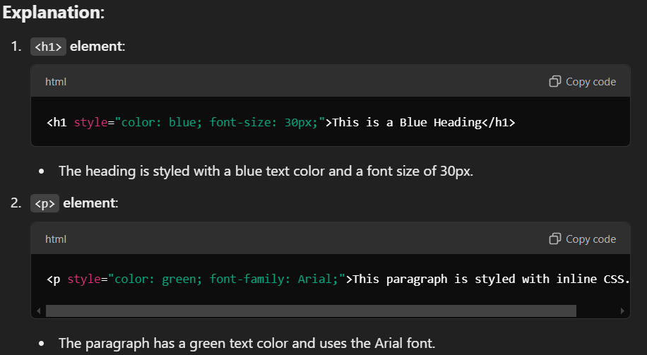

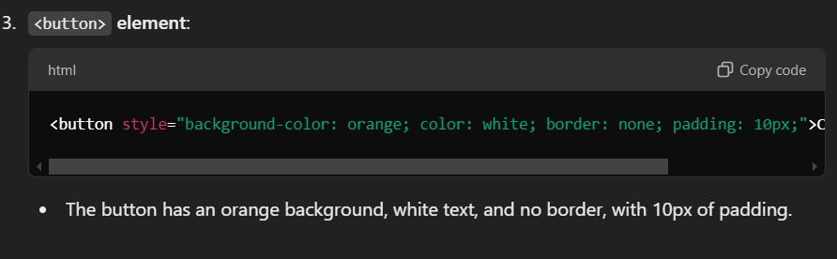

Pros and Cons of Inline Styles:

Pros:
- Quick and Simple: Easy to apply styles to individual elements without needing a separate CSS file or a <style> tag.
- No External Dependencies: Useful when styling a single element or for very small projects where an external stylesheet may not be necessary.
- Immediate Effect: Styles are applied directly to the element, making them easy to modify in one location.

Cons:
- Lack of Reusability: Inline styles cannot be reused across different elements, which makes the code repetitive and hard to maintain.
- Harder to Maintain: Large-scale projects with many inline styles become difficult to manage and debug.
- Separation of Concerns: Mixing HTML structure and CSS styles in the same file goes against best practices, as it breaks the separation of content and presentation.
- Increased HTML File Size: Inline styles make the HTML file larger and can affect loading time if overused.

